Project Title:
Website UI Redesign for Improved Usability

Name: Dhanasri K
Internship: UI/UX
DESIGN INTERNSHIP
Date: 02.05.2026
INTRODUCTION
UI Redesign:
User Interface (UI) redesign is the process of improving the visual layout, usability, and overall user experience of an existing website or application. It focuses on enhancing how users interact with the system by making it more intuitive, visually appealing, and easy to navigate.
UI redesign involves analyzing existing problems, applying design principles, and creating improved layouts that provide a better experience for users.
Objective of the Project
The main objective of this project is to redesign an existing website interface to improve usability and user experience. The project focuses on:
- Identifying usability issues using heuristic evaluation
- Creating a clean and modern design
- Improving navigation and user flow
- Designing responsive layouts for desktop and mobile
- Applying visual hierarchy and consistency

PROBLEM IDENTIFICATION
Heuristic Evaluation
The existing website was analyzed using usability principles to identify key issues.

Identified Issues:
1. Poor Navigation
- Users find it difficult to locate important sections
- Violates: Visibility of system status
2. Cluttered Interface
- Too many elements on the screen create confusion
- Violates: Aesthetic and minimalist design
3. Lack of Feedback
- No confirmation after user actions (e.g., button clicks)
- Violates: User control and freedom
4. Inconsistent Design
- Different styles of buttons and fonts
- Violates: Consistency and standards

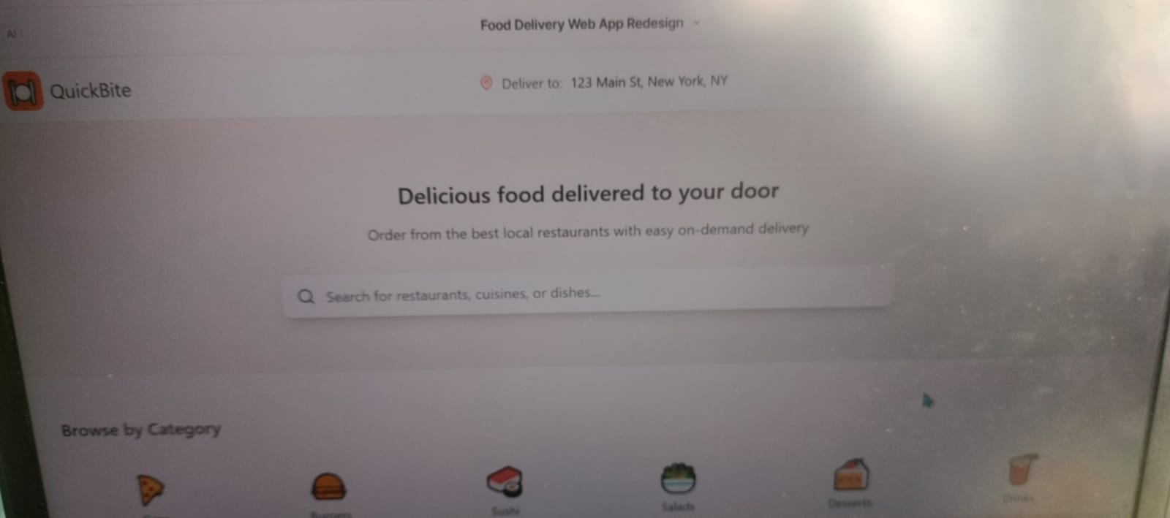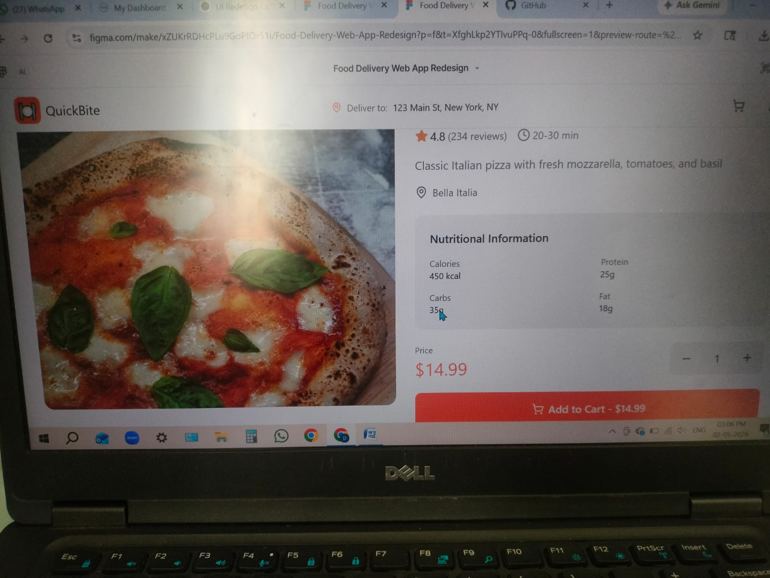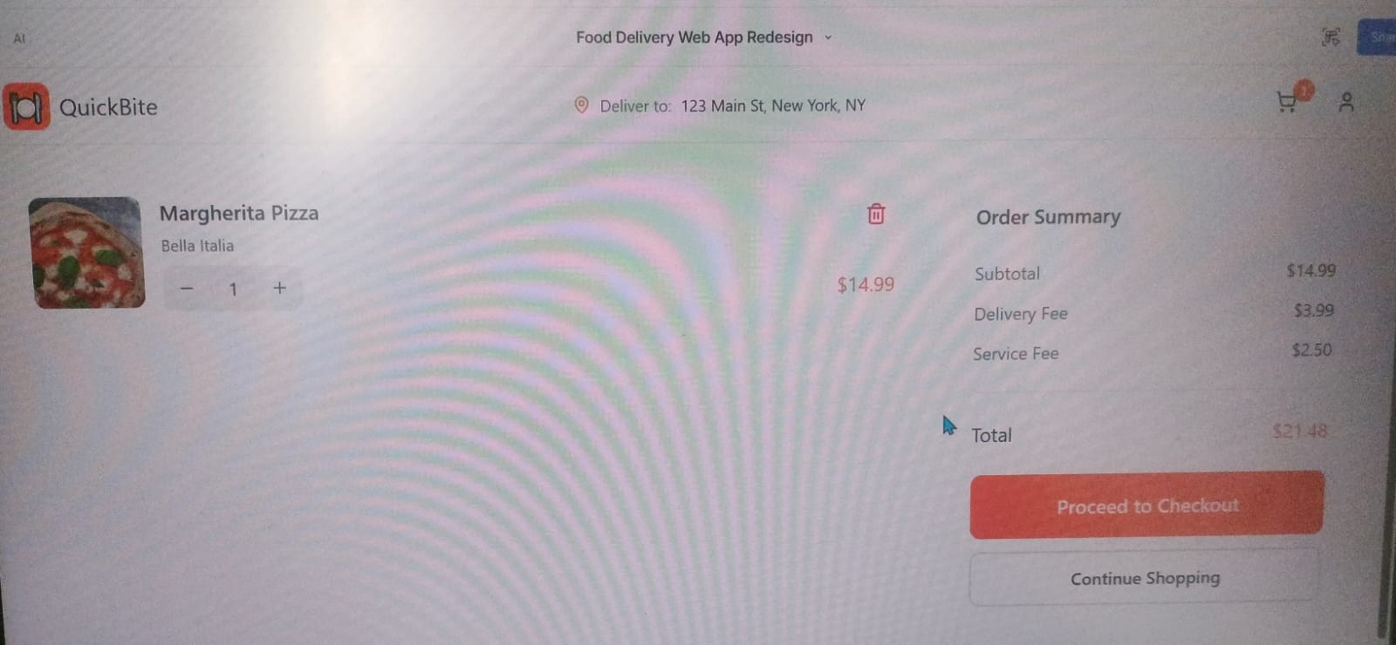
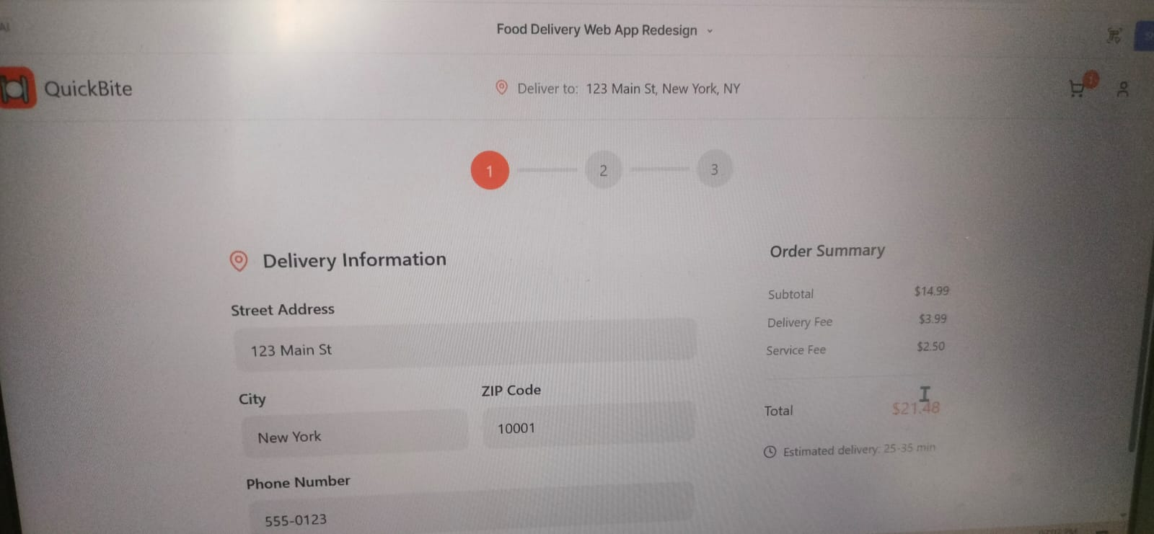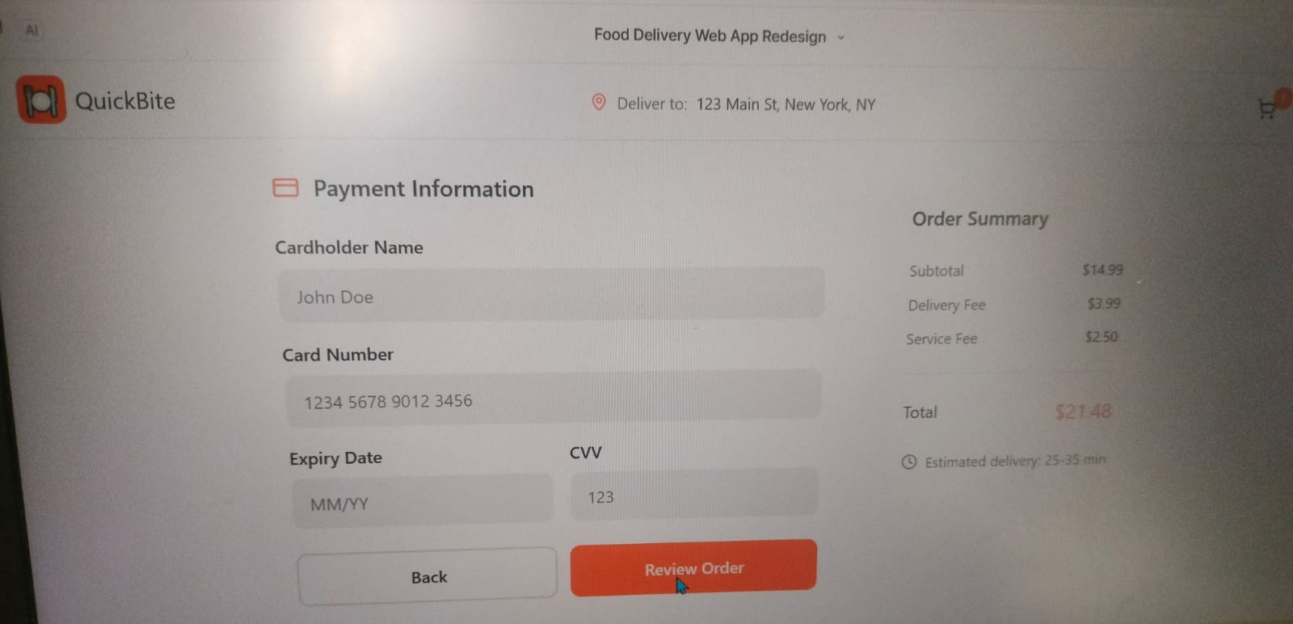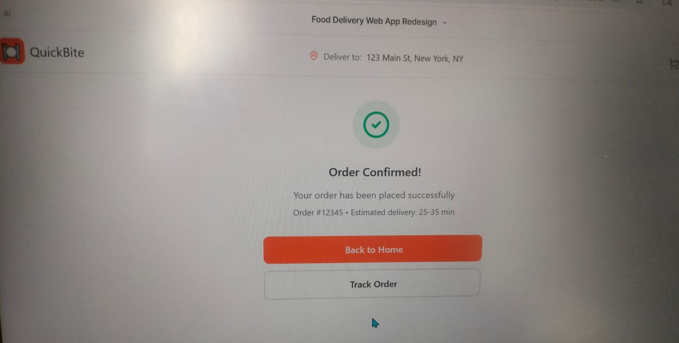USER PERSONA
Name: Priya
Age: 21
Occupation: Student
Goals:
- Quickly browse and order food
- Simple and fast checkout process
Pain Points:
- Confusing layout
- Too many steps to complete tasks
- Lack of clarity in navigation

MOOD BOARD
The mood board was created to define the visual direction of the design.
It includes:
- Soft and modern color palette
- Clean and minimal UI inspirations
- Simple and readable fonts
The goal is to create a visually appealing and user-friendly interface.
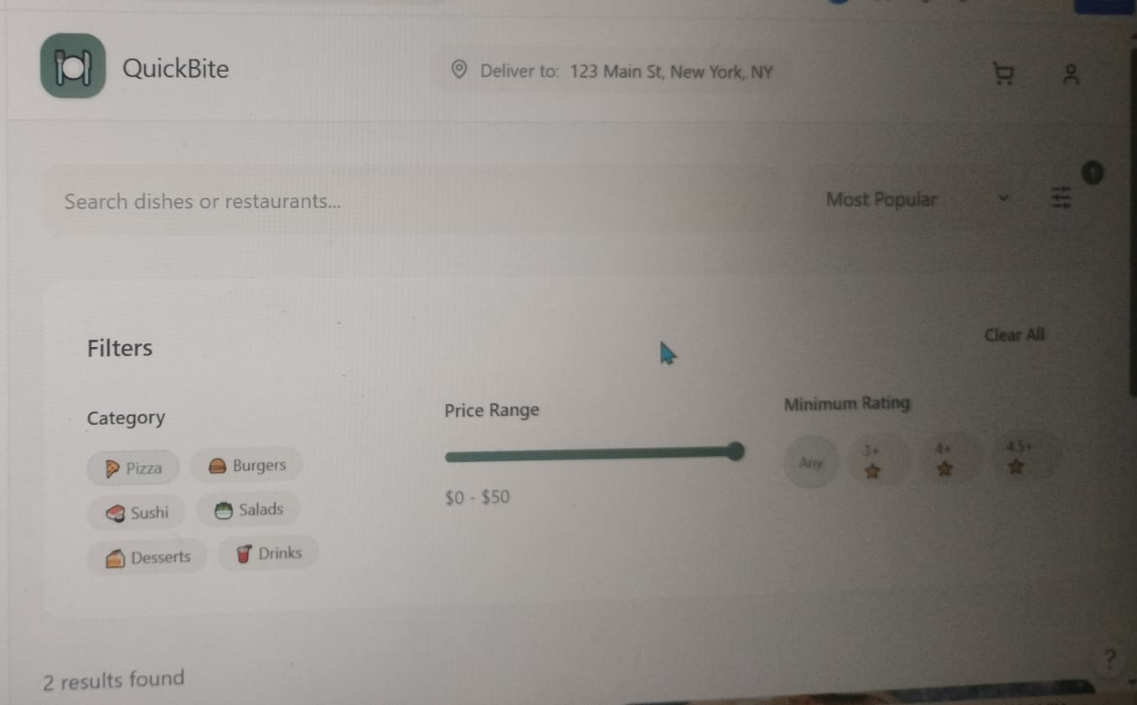

STYLE GUIDE
A consistent design system was created to maintain uniformity across all screens.

Includes:
Colors:
- Primary color
- Secondary color
- Background color
Typography:
- Heading font
- Body text font
Components:
- Buttons
- Cards
- Input fields
This ensures consistency and improves the overall user experience.
FINAL UI DESIGNS
High-fidelity designs were created using Figma with proper colors, typography, and components.

Screens Included:
- Homepage with search and categories
- Product listing page
- Product details page
- Cart page
- Checkout page
The design focuses on:
- Clean layout
- Easy navigation
- Clear call-to-action buttons
CONCLUSION
The redesigned website provides a clean, modern, and user-friendly interface. By applying usability principles and improving layout structure, the new design enhances navigation and reduces user effort.
Overall, the project successfully achieves improved usability and better user experience.

